|  |  |
| --- | --- |
| **DAY** | **DOORS OPEN** |
| ***Monday*** | **8:00am — 6:30pm** |
| ***Tuesday*** | **8:00am — 6:30pm** |
| ***Wednesday*** | **8:00am — 6:30pm** |
| ***Thursday*** | **8:00am — 6:30pm** |
| ***Friday*** | **8:00am — 6:30pm** |
| ***Saturday*** | **CLOSED** |
| ***Sunday*** | **CLOSED** |

***REMINDERS:***

**A GP appointment is 10 minutes long which is not long enough for multiple problems.**

**Repeat prescriptions will not be available for collection**

**after 6.30pm or at weekends.**

**DESPITE THE NHS BEING IN CRISIS AND DEMAND FOR OUR SERVICES BEING EXCEPTIONALLY HIGH, WE WILL ALWAYS BE DOING OUR VERY BEST!**

**PLEASE BE KIND!**

**Telephone: 01246 273224 *(8am to 6pm)***

**Cancellation Line: 01246 212840 *(24hrs)***

**Out of hours Service: 111 *(24hrs)***

**Church Street**

**Brimington**

**Chesterfield**

**S43 1JG**

*www.brimingtonsurgery.co.uk*

**Working to deliver the highest quality care.**

**Every patient matters.**

**THE BRIMINGTON SURGERY**

**Practice Leaflet**

**We offer a limited number of appointments some evenings, early mornings and weekends – please ask the Patient Support Team should you require weekend or evening access.**

**We close for training one Wednesday afternoon per month - dates will be advertised in the surgery and on our website.**

**We are not open on Bank Holidays.**

***Last updated — April 2024 v7.8***

Care Quality Commission Rating: GOOD

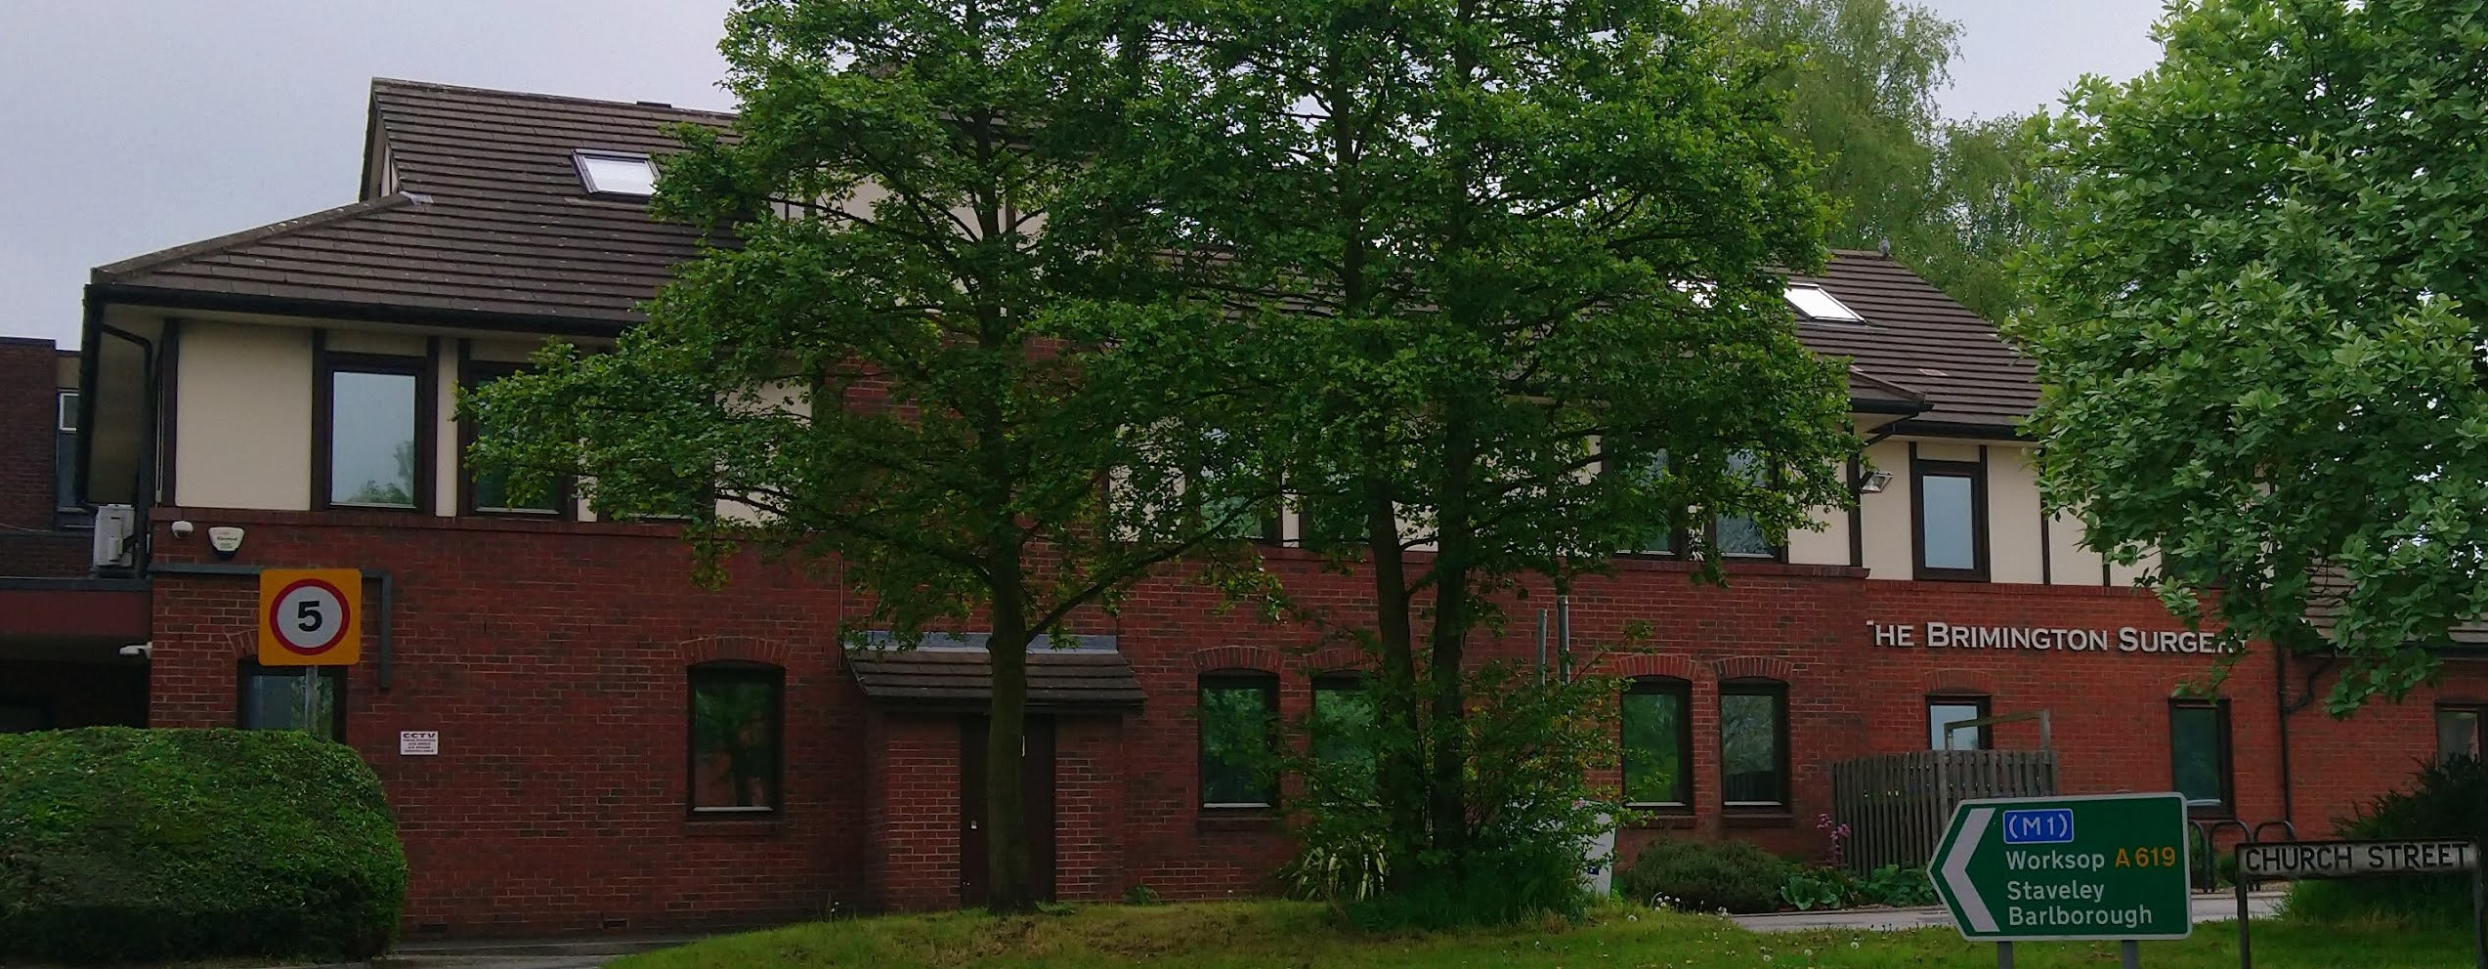

**ZERO TOLERANCE**

**We ask that ALL our staff be treated with respect at ALL times.**

A zero-tolerance policy against *(but not limited to)* unreasonable requests, inappropriate, abusive, rude or aggressive language, sexist, homophobic, biphobic, transphobic, or racist comments, threatening or violent behaviour is in place throughout the NHS.

The team at The Brimington Surgery have the right to do their work in an environment free from such behaviour and at no time will any such behaviour be tolerated in this practice.

If the rights of our staff and patients are not respected, we may choose to inform the police and arrange for patients to be removed from our medical list should this be deemed necessary.



**All information in this leaflet can be made available in alternative formats, such as large print and audio. Subject to reasonable request we may also be able to provide information in alternative languages.**

**OUR TEAM**

The Doctors of The Brimington Surgery provide Standard General Medical Services and hold a contract with Derby & Derbyshire Integrated Care Board (DDICB)

***GP Partners:*** *Dr. Emma Fordham MBChB DRCOG DFFP — (F)*

*Dr. Rupert H White BM BS MRCGP — (M)*

*Dr. Maria Roberts MRCGP BMBS BMedSci — (F)*

*Dr. Louise Bellingham MBChB MRCGP — (F)*

***GPs:***

*Dr. Marzena Whittaker MBChB MRCGP MRCP— (F)*

*Dr. L. Jolene Briggs MbChB DRCOG MRCGP — (F)*

*Dr Nathalie Rebora MRCGP — (F)*

*Dr Tess Hardwick MBChB MRCGP DRCOG* - *(F)*

*Dr Esther James MRCGP (F)*

***Community Matron:*** *Fran Mossman*

***Nurse Practitioner/Lead Nurse:*** *Lisa Baldran*

***Practice Nurses:***

*Lindsey Rodgers Diane Smith Joanne Luxton*

***Assistant Practitioner:*** *Mandy*

***Healthcare Assistants/Phlebotomists:***

*Gemma Kim*

***Practice Manager:*** *Paula Elliott*

***Deputy Manager:*** *Chelsea Webster*

***Administration Team Leader:*** *Jo H*

***Patient Support Team Leader:*** *Juliet*

***Patient Support Team Deputy Team Leader:*** *Alice*

***Care Co-ordinator:*** *Ros*

***Administration Team:*** *Leanne, Lisa & Jo M*

This team is responsible for clinical coding, processing requests for reports, forms, referrals and letters and dealing with incoming and outgoing post.

***Patient Support Team:*** *Amy, Faye, Natalie, Sarah B, Sarah C & Sonia*

This team is here to help you and to assist in the efficient running of the surgery for the benefit of all patients. They have undergone enhanced training and may, need to ask you for clinical details to ensure you are booked with the correct Clinician.

***Patient Co-ordinator Team:***

*Debbie – Patient Co-ordinator; Sammy – GP Assistant;*

*Nicola – Recalls Supervisor*

This team of experienced practice staff will be working directly with the clinicians to ensure smooth and efficient running of the service.

Our ***Nurse Practitioner*** is very experienced and has undergone extensive additional training to enable her to treat common health problems. Her role is to see some of the same day urgent cases, which enables patients to be seen quickly and efficiently.

Our PCN Employed ***Pharmacists*** (see ARC Primary Care section)run clinics and conducts medication reviews. You may be offered a face to face or a telephone appointment where a GP has deemed this to be appropriate.

The pandemic has taught us that not all patients will need to be seen face to face and we provide telephone and video appointments too.

**If you are asked to come for a face-to-face appointment at the surgery, please remember to use the check-in screen or inform our Patient Support Team when you arrive.**

**PATIENT RIGHTS AND RESPONSIBILITIES**

**As a patient with Brimington Surgery you have a right to:**

* Receive treatment regardless of your age, gender status, sexuality, ethnic origin, religious beliefs, disability or nature of your health problems as long as you reside within the practice boundaries and qualify for NHS treatment. *Details of the practice boundary can be obtained from the reception staff or via our website*.

* Confidentiality

* Gain access to an interpreter

* Have your treatment explained to you

* Be treated with courtesy and dignity

* Have a relative, friend or chaperone with you

* Refuse to be treated in front of any medical students

* Complain, without discrimination if there is a problem

**You are responsible for:**

* Making and keeping appointments.  Please notify the surgery in good time if you are unable to keep a booked appointment.

* Ordering repeat prescriptions in good time using the advised methods.

* Behaving in a courteous and polite manner to all members of the practice and public.

* No inappropriate, abusive, rude or aggressive language, sexist, homophobic, biphobic, transphobic, or racist comments, threatening or violent behaviour.

* Keeping the content of telephone calls to the current problem.

* Keeping the duration of telephone calls to a reasonable length, considering the needs of other patients and accepting realistic expectations of the practice.

* Informing the practice of any change of name, address or telephone number.

* Keeping young children in your care under supervision and ensuring they behave appropriately.

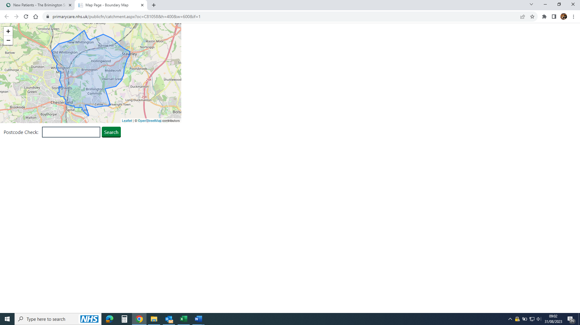

**ATTATCHED STAFF**

**Staff employed by Derbyshire Community Health Services who provide services to our patients include:**

**District Nurses** whoprovide a nursing service to our housebound patients. They can be reached between 8am-6.30pm via the Access Point Line - 01332 564900.

**Health Visitors** who can be reached via the Derbyshire Family Helpline01246 515100.

**The Midwifery service** is based in Inkersall and can be contacted by telephoning 01246 470 684.

**TRAINING PRACTICE**

We are an approved training practice. Our GPs supervise fully qualified doctors, who have spent a number of years working in a hospital environment. Some of these have decided to specialise as a GP.

These Registrars will spend up to a year working at the practice. In total they will have studied for 10 years and worked as doctors for several more.

We also support training for Nurses, Nurse Associates and GP Assistants and welcome younger potential medical students whenever we can.

You will always be asked if you are happy for a trainee to be present for your consultation and ALWAYS have the right to decline.

**NEW PATIENTS**

In order to apply to join our practice, you will need to fill in our patient registration form. Please return this along with proof of address and photo ID if you have these.

Please speak to our Patient Support Team if you have any concerns regarding this.

You may need a New Patient appointment and it is important that you attend. It can take a little while for your records to arrive from your previous surgery.

Our website, **www.brimingtonsurgery.co.uk** has a facility to check whether you are in our practice area also to apply to register. Our Patient Support Team is also able to advise you.

**TEMPORARY RESIDENTS**

We are always happy to see any relatives or friends staying with you if they need a Doctor or Nurse **urgently.** Temporary resident appointments criteria is based around treatment that is ‘immediate and necessary’.

**HALF DAY MONTHLY CLOSURE**

*Dates will be advertised in the surgery and on our website.*

This session allows our team to undertake extra training in many diverse subjects such as: Autism Awareness; Dementia Friends; Anti-discrimination Training; Carer Awareness; Learning Disability Support; Sepsis Awareness along with mandatory training in Fire Safety; Information Governance; Basic Life Support; Confidentiality and many more important areas.

The Brimington Surgery is proud to be one of the first practices in the area to hold the Gold Pride in Practice Award for excellence in LGBT healthcare which is nationally recognised and endorsed by NHS England, the Government Equalities Office and the Royal College of GPs.

The surgery is also a "Safe Space" and holds the Derbyshire Dignity Award. We are an Armed Forces Veteran Friendly Practice.

**ACCESS TO THE SURGERY AND SERVICES**

All the practice premises have suitable access for disabled patients. We have special toilet facilities on both floors and a lift between the ground floor and first floor. There are two disabled parking spaces in the council car park immediately outside the surgery. If you have any special or particular difficulties, we are here to help. Please ask us!

We also have a hearing loop installed in the reception area, and a portable hearing loop for use during consultations. Please ask at reception.

**Interpreter Services**

We can provide interpreter services for most foreign languages and for British Sign Language. Please inform the Patient Support Team at the time of booking your appointment so that this can be arranged in advance.

**CHESTERFIELD AND DRONFIELD PCN/**

**ARC PRIMARY CARE**

The 7 Chesterfield GP Practices:

*The Brimington Surgery; Calow & Brimington Practice; Chatsworth Road Medical Centre; Inspire Health; Newbold Surgery; TheSurgery@Wheatbridge and Whittington Moor Surgery*

and the 3 Dronfield Practices:

*Dronfield Medical Practice; Oakhill Medical Practice and Stubley Medical Centre*

have formed a Primary Care Network in line with Government Policy and the NHS England Contract. We work closely together for our combined population.

ARC Primary Care employs over 70 staff in various teams:

*Social Prescribing Link Workers* are based in practices. Their role is to give people time, focusing on what matters to that person, identified through shared decision making or personalised care. They offer support planning by linking them with suitable services or groups. Karin is based at our practice and works with us on Mondays and Thursdays.

*The Pharmacy Team* also work in Practices and our Lead Pharmacist is Dhiren, supported by Pharmacy Technician Sheralyn.

The Ageing Well Team look after the Care Homes in our area, run Learning Disability Health Reviews and undertake acute home visiting Team. This team consists of Doctors, Advanced Nurse practitioners and Nurse Associates – if you request a home visit and are suitable for their service, they are likely to visit you in place of your usual GP

ARC/PCN is based at the Dunston Innovation Centre, Chesterfield.

**ENHANCED ACCESS**

This is a service, commissioned by NHS England part of the Government’s General Practice Forward View’ Programme.

Our PCN has used this as a true test of collaborative working, with each of the ten practices providing, or delegating, a number of appointments between 6.30pm and 8pm Monday to Friday and 9am til 5pm Saturday, calculated on 30 minutes of appointments per 1,000 patients.

These appointments are pre-bookable via your practice and are likely to be at Brimington Surgery, however, you might be offered an appointment at one of the other 6 sites in Chesterfield.

To be seen at another site you will be asked to share your record with the “Hub”, be assured that the Practices have signed an Information Sharing Agreement which governs the appropriate use of patient data in order to provide Health Care Services. Existing confidentiality clauses ensure that all employees access data appropriately and in a fully audited manner.

You may get an automatic SMS confirmation of this appointment which will inform you that your appointment is in "The Hub" however on booking your appointment you should be informed verbally where this appointment actually is (if it is face-to-face). You should also receive a text confirming this which - will be manually sent.

**If you need to cancel your "Hub" appointment when we are closed, please phone 01246 957549**

**and follow the instructions.**

**DERBY AND DERBYSHIRE INTEGRATED CARE BOARD**

GPs Derby and Derbyshire have been working together to build the strong foundations required to take on new commissioning responsibilities as part of the NHS reforms and with patients being at the heart of decision making with ‘no decision about me without me’**.**

**Derby and Derbyshire ICB**  
Cardinal Square,  
10 Nottingham Rd,  
Derby, DE1 3QT

**Telephone:** 01332 01332 981601

<https://joinedupcarederbyshire.co.uk/derbyshire-integrated-care-board/>

<https://joinedupcarederbyshire.co.uk/contact-us/>



**CHANGE OF DETAILS:**

If you change your name, phone number or address it is important that you let us know so we can update your records.

**Summary Care Record (SCR)**

This is an automatically created real time electronic record which includes your medication, adverse reactions and allergies.

Having this information stored in one place makes it easier for healthcare staff to treat you outside of your GP practice.

You can change your mind at any time about whether or not you have a Summary Care Record, but you will need to tell us.

**Summary Care Record – SCR Additional Information**

This is an additional enhancement to the SCR described above. You will need to explicitly request this and it will include:

Significant problems & procedures (past and present)

Anticipatory care information and communication preferences

End of life care information, Immunisations.

Sensitive items related to IVF, STDs, terminations, gender re-assignment etc. are automatically excluded so if you require these to be included you need to provide specific consent for these to be added.

**Sharing methods outside of GP services**

Information is ONLY shared with appropriate professional services who have undergone security assessments (e.g. Ambulance and Out of Hours Services, Community Health; Social Care) and are working with you to provide support, so your information is available when it is needed most.

These Professionals must still ask for your consent to view certain information when treating and supporting you, which means that you are always presented with an option to agree or disagree.

The only exception is ‘duty of care’, which means that confidentiality can be over-ridden, if, for instance, there are safeguarding concerns about someone’s welfare or in a medical emergency and consent cannot be obtained.

**HOME VISITS**

If you think you need a home visit because you are **completely** unable to get to the surgery, please call us before 10:30am to request a home visit so that visits can be arranged effectively.

Home Visits are for patients who are truly housebound because for every four patients consulted in the surgery, we can only see one person at home. Facilities for examination are often not suitable in a home environment.

Your request will be assessed by the on-call GP and may be passed to our PCN Acute Home Visiting Team.



**CANCELLING APPOINTMENTS**

 Please do this as early as possible in order for us to use it for someone else:

* Leave a message on our 24/7 voicemail line 01246 212 840.

*Ensure that you leave your name, date of birth and date and time of the appointment*

* OR you can use the SystmOnline or NHS App cancellation facility.

**MISSED APPOINTMENTS**

When patients do not attend their appointments, this time is wasted. In an attempt to try and resolve this, the practice has developed a ‘DNA’ (Did Not Attend) policy. If your appointment is missed, you should receive a text message letting you know that you have not attended. If you continue to fail to attend, we may class this as a breakdown of Practice/Patient Trust and you may be removed from the practice list and have to find an alternative GP practice.

**PATIENT CONFIDENTIALITY AND DATA PROTECTION**

We ask you for personal information so that you can receive appropriate care and treatment. This information is recorded on computer and we are registered under the General Data Protection Regulations. The practice will ensure that patient confidentiality is maintained at all times by all members of the practice team. For the effective functioning of a multi-disciplinary team it is sometimes necessary that medical information about you is shared between members of the practice team.

Everyone working in the NHS has a legal duty to keep information about you confidential and secure. Access to records is in a coded format across secure NHS networks and trained staff have a Chip and Pin smartcard with relevant access rights embedded in it.

You can register to view your record online – if you are already registered for SystmOnline, just ask our team to have this added to your access profile. Or to register for online access, contact us and we will process your request.

**General Data Protection Regulations (GDPR)**

The Practice fully complies with GDPR. Under the data protection legislation patients have a right to be informed whether personal data about them is being processed and have the right of access to the data. Further information is available on our website or we can provide our policies on application.

**Sharing your records with other providers of your care**

Unless you tell us otherwise, other professional providers of your care will be able to view limited parts of your records BUT unless you are medically unable to respond at the time of treatment, you will ALWAYS be asked for your consent.

**TEXT MESSAGING**

We offer a text reminder service for appointments at the surgery. If you provide a mobile telephone number you will receive an automated message prior to your appointment to remind you. ***However, please ensure you also write your appointment down as sometimes there are technical issues beyond our control.***

We will also send text messages related to your wider healthcare. Please tell us if you **DO NOT** wish to receive any SMS from us.

**OUT OF HOURS:**

If you need to speak to a GP or see somebody after the surgery is closed, you can contact the out-of-hours GP service by dialling 111.

You can contact this service for advice even if you feel that your condition is not urgent or serious.

Dialling 111 will get you through to a team of highly trained advisers, who are supported by experienced nurses. They will assess your symptoms and give you the health care advice you need to direct you to the right local service. If required, they will arrange for you to be seen/call an ambulance.

**TEST RESULTS**

These are available **after 3.00 p.m**.

Please note that we have a strict policy regarding confidentiality. We will only give out results to the person they relate to, unless that person has given prior permission for their release.

If you have online access, you may be able to see your results even before the clinician has reported on them. Please allow us time to review these before contacting us. If you view your results online, they will automatically be marked as "patient informed" by the IT system.

as "patient informed".

**SELF CARE**

***It is estimated that every year 50 million visits to the GP are made for minor ailments such as coughs and colds, mild eczema, and athlete's foot that can be easily resolved without a doctor's appointment.***

To help the pressure on service, ***PLEASE*** try self-care for minor symptoms ***BEFORE*** contacting us or try your local pharmacy.

## Self-care refers to the actions we take to recognise, treat and manage our own health.  It is about doing small, everyday things for yourself:

**QUICKER** – no need to wait for a GP appointment. Keep a well-stocked medicine cabinet at home to help you treat minor ailments.

**EASIER** - Colds, coughs, indigestion and many other minor complaints can all be treated with over-the-counter medicines from your local pharmacy or supermarket.

**SIMPLE** – advice and information about self-care is widely available online.  You can also call into any pharmacy for advice on the best treatment for your minor illness.

**CONSIDERATE** – Self-care helps relieve pressures on GP Practices and A&E

**Always follow the instructions on the medicine label and consult your doctor if the illness continues or becomes more severe.**

**PATIENT PARTICIPATION GROUP (PPG)**

The practice has a Patient Participation Group to encourage open discussion of changes and ideas within the practice which was originally established in 2008.

Our PPG meetings are open to all members of the practice.  Consequently we do not have a fixed number of members of the group, but on average there are approximately fifteen attendees.

If you are interested in joining our Patient Participation Group, please speak to our Patient Support Team at Reception for further information.

**PATIENT FEEDBACK**

Our aim is to give you the highest possible standard of service at all times and to deal swiftly with any problems that may occur.

We recognise that occasionally things do not go as smoothly as we would like. If you have a complaint or concern about the service you have received, please let us know.

Please also let us know when you think we have done something well or if you have any suggestions as to how we can do something better.

We have a formal procedure to deal with any complaints about the services we provide. Our Managers will provide further information to support you through the process.

Copies of our family and friends feedback forms are available on the reception counter and under Online Forms on our website. We can also send this to you via SMS.

***Please note: We require at least two full working days’ notice*** to process a prescription. If possible, order your repeat prescription at least a week before your medication is due to run out.

**ELECTRONIC PRESCRIPTION SERVICE (EPS)**

Prescriptions are now sent directly to a pharmacy, making things easier for you. You can go straight to your chosen pharmacy and collect your medication. No need for paper or a visit to the surgery!

Electronic prescribing is a more reliable, secure and confidential NHS service. Unlike paper prescriptions, electronic prescriptions can't get lost between the doctor and the pharmacy and can be easily tracked.

It’s easy and you do not need a computer to use this service!

Ask practice staff for more information.

**ELECTRONIC REPEAT DISPENSING**

Electronic repeat dispensing allows you to obtain repeated supplies of your medication without you having to request your prescription each month.

This means that your GP can issue a batch of repeat prescriptions to last you until you are due for your next review (subject to the type of medication and if your illness is stable). The prescriptions will then be available from your nominated pharmacy for collection each month as normal without you having to visit the surgery!

Prescriptions will still be dated for safety, so that medication is not able to be collected too early.

Please speak to the Patient Support Team for more information.

Some pharmacies offer a home delivery service for eligible patients please ask your usual chemist for further information.

**COMMUNITY PHARMACISTS**

They offer professional free health advice at any time - you do not need an appointment. From coughs and colds to aches and pains, they can give you expert help on everyday illnesses. They can answer questions about prescribed and over-the-counter medicines, advise on healthy eating, obesity and giving up smoking.

**Pharmacy First Service** - Most Pharmacies are part of this and can treat the following with some restrictions: UTIs; Shingles; Impetigo; Infected insect bites; Sore throats; Sinusitis; Otitis Media.

They may suggest you visit your GP for more serious symptoms.

We may signpost you to the Pharmacy First Service when you contact us.

Many medications are available to purchase without a prescription.  They can advise on what you might find useful to keep in your medicine cabinet.

**REPEAT PRESCRIPTIONS**

If you are on regular medication, then you can often order a repeat prescription without needing to see the doctor.

You can phone the Medicines Order Line on 01246 588860 to place an order or use the online link on our website.

You can order online *—To register for this service please contact the surgery where a member of the Team will ask you questions to verify your identify and generate a password for you. Once you have registered, you will be able to go online to start ordering your repeat medication via the icon on our website.*

OR on the NHS App.