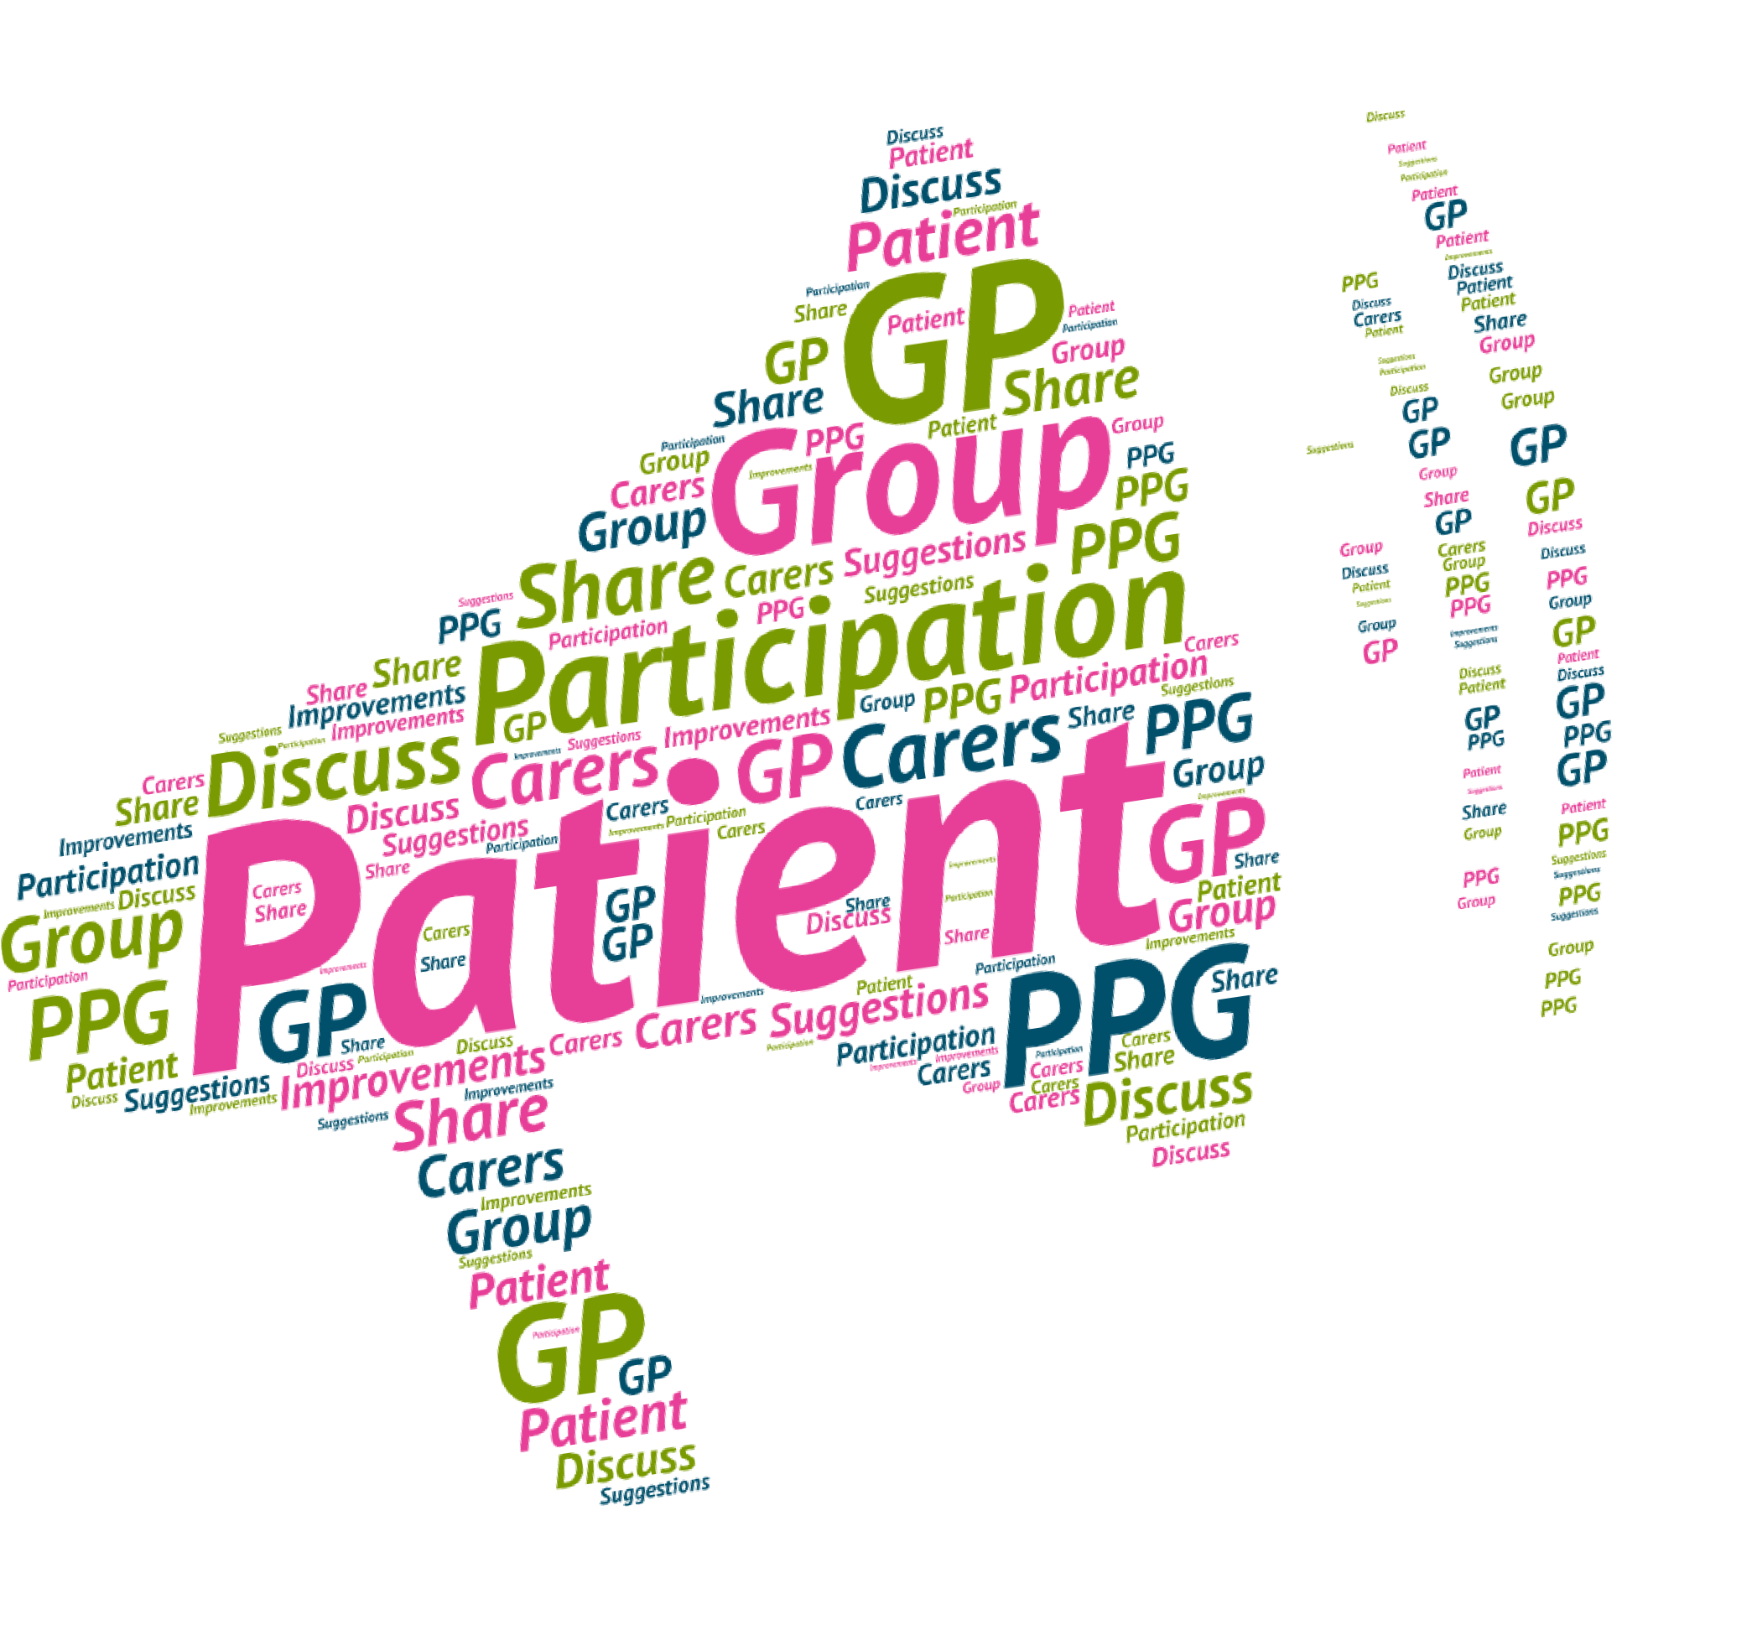
A Patient Participation Group (PPG) is a group of patients, carers and GP practice staff who meet to discuss practice issues and patient experience to help improve the service.

THE BRIMINGTON SURGERY

Patient Participation Group –

Best Practice Guide

Extra Support for Your PPG

There are lots of resources available to support PPGs, their members, and the GP Practices they belong to. Patients must feel they can contribute in a meaningful way otherwise they may not want to continue attending PPG meetings.

Nominated PPG members can also attend PPG Area meetings if they are run locally, to represent their GP practice and learn from the experiences of other PPGs.

Training
Contact your local Healthwatch or your local ICB to find out what training sessions are available for patients and staff to attend.
https://www.healthwatchderbyshire.co.uk/reports-and-publications/patient-participation-group-guide

National Association for Patient Participation (NAPP)
NAPP provides a number of PPG resources and information to support the development of PPGs, as well as ideas for meeting topics. Practice PPGs can choose to become members of NAPP by paying a joining fee and receiving a number of regular benefits and resources. Visit www.napp.org.uk for more information.

For further information and queries please contact:
ppg.brim@gmail.com or ask at Reception

The Brimington Surgery, Church Street. Chesterfield
S43 1JG.

June 2025 v1

Ideas for Recruiting More Patients

to Your PPG
Create a large poster advertising the PPG, which has a small amount of text and says clearly what the group is, when they meet and how to register.

Use the electronic display to advertise the PPG if you have one.

Practice staff can help identify patients who might be interested, and approach them face to face to tell them about the group.

If you already have PPG members, some may be willing to spend an afternoon sitting in the practice, talking to patients in the waiting room and signing them up there and then.

Create a PPG page for the practice website.

Advertise the PPG at local community hub spaces with posters.

Have an open day with useful information on particular health topics for all interested patients to attend.

Tell patients about the group as soon as they register with the practice and when they pick up repeat prescriptions.

Advertise the PPG using the text message service.

Contact your local Healthwatch to assist in telling people about your PPG.

Purpose of a PPG:

- To give patients and practice staff the opportunity to meet and discuss topics of mutual interest.

- To provide a means for patients to become more involved and make suggestions about the healthcare services they receive.

- To explore issues from patient complaints and patient surveys, contribute to action plans and help monitor improvements.

- To contribute feedback to the practice on National Patient Survey results and Friends and Family Test feedback to propose developments or change.

- To support health awareness and patient education.

What should a PPG look like?

A PPG is open to every patient on the GP practice list. All communities, groups, genders, ages, ethnicities, and disabilities representing the patient list are encouraged to join.

There are no other membership requirements except that patients must be registered with the practice.

PPG members should as far as possible, be representative of the practice population. In some cases, the practice can ask for support from their local Healthwatch to assist in the recruitment of patients.

How to make your PPG more representative:

Having a PPG that represents the diversity of your patient population is important in making sure the GP surgery is meeting the needs of its patients, by listening to a variety of patient voices.

There are many things PPGs can do to engage a wider range of patients:
- Create a Suggestions and Compliments Box that sits in the waiting room.

- Advertise the PPG amongst local community groups with the support of local voluntary organisations like Healthwatch.

- PPG members can attend local community group meetings.

- Invite local voluntary organisation representatives to PPG meetings, to share PPG information with the people they work with.

- Practice/PPG members can go out into the community to consult with particular seldom-heard groups.

- Practice can host information sessions/events that are relevant to particular community groups to reign in interest.

- GP Practices can engage with Healthwatch and receive feedback from seldom-heard groups about their GP practice, to take to future PPG meetings.

What types of PPGs are there and
how should they work?
Face to Face
The practice staff should make sure that everyone in the group is clear about what is and what is not to be included in group discussions or actions.

Poor planning is one of the main reasons why patient groups fail, so it is important that the group formulates an action plan. These can include short term, and long term goals, with timescales for when tasks need to be completed.

Meetings should be set for 1.5 hours, unless PPG members have specifically requested more time.

A PPG should aim to meet at least 4 times over a year (quarterly) but can meet more often if the group chooses to do so. Usually, a PPG will meet within the GP practice at a time suitable for all patients – this could be daytime or evening depending on your practice population.

A PPG should always block out time during these meetings for the practice to give patients any information about changes to the practice’s services, and for patients to bring up any issues they feel could affect the wider practice population.

- Information will be given to patients through poster displays and the practice newsletter.

Rules Governing the Group
- The group shall elect a chair to serve for a period of two years (with a start date set of January) and will be elected at a PPG meeting. Meeting at the practice will be held quarterly.

- The group will consist of at least a core group of 4 patients.

- A copy of the minutes from the PPG meeting will be sent out to members via the Secretary and are also available on request or on the practice website.

The Brimington Surgery Patient
Participation Group Constitution
The group shall be known as The Brimington Surgery PPG. Membership will be open to any patient registered with the practice and will include the Practice Manager or other practice team members as representation from the practice. Membership will be via the meeting group or the virtual group.

Aims
- The group will provide a communication channel between the patients and the practice.
- With the help and assistance of practice, the group will seek suggestions from patients for improvements to the service and highlight any areas that need attention.
- The group will assist the practice in monitoring quality through patient participation.
- The group will develop short term and long term goals, reviewing these regularly.

Objectives
- Communication: The group will influence the development of policies in the practice by representing patient views. This will ensure patients make the best use of the facilities available.
- Surveys: The group will conduct surveys with patients to inform the action plan.
- The group will work with the practice to ensure changes are fed down to local community groups.
- The group will be informed of the commissioning plans and policies of the CCG and engaged in consultations when required.

Virtual
Practices can set up a virtual group for patients who want to contribute to improving services in the practice but cannot attend face to face meetings.

Set up an email address specifically for PPG members, which is used to communicate with patients and consult with them on a range of topics that affect the practice.

Use social media to communicate with a wider range of patients.

Use MS Teams for virtual face to face meetings.

Designated staff responsible for communicating with the virtual PPG should ensure they have regular communication with the group, keeping them updated with any changes happening in the practice.
Members should be asked regularly to provide comments and suggestions over email, just as they would in a face to face group.

If virtual members decide they want a face to face group, this can be made possible by the practice. They might meet less frequently than other face to face groups, as these meetings would be in addition to the virtual group.

Dissolution
- If the PPG considers it appropriate to dissolve, patients will be notified of the proposal, in writing, such notice to be displayed in the waiting room. Full explanation will be given as to the reasons for the dissolution and patients will be invited to the next available meeting where the proposal may be upheld or suspended.

- Notice should be given at least one month before the proposed final meeting of the PPG. Reasons for the dissolution or other action to be duly recorded in the minutes and published.

PPG Do’s

- Discuss constructive suggestions for improving the practice and share concerns that could affect the wider practice population.

- Organise health focused events with the practice, i.e. healthy eating awareness as an information event for all practice patients to attend.

- Create a patient survey with practice staff, to get feedback about the practice from the rest of the patient population.

- Design a newsletter for the practice, to provide regular updates to patients.

- Assist the practice in making sure their website is ‘Patient Friendly’.

- Engage with the local community via fundraising events and useful health information, to ensure the PPG is representative.

- Invite health and voluntary professionals to PPG meetings, for PPG members to remain informed and updated about local opportunities for patients.

Best Practice Example:
A PPG member at X Medical Centre wanted to raise a formal complaint during the meeting about not receiving their prescription.
The Chair of the meeting suggested the patient speak to the Practice Manager after the meeting to resolve the issue.

Meetings

- The PPG will meet at least 4 times a year and these meeting dates will be set in advance.

- Members will send apologies in advance of the meeting if they are unable to attend.

- Practice staff will send apologies in advance of the meeting if they are unable to attend allowing enough time for the meeting to be rescheduled if deemed necessary.

- A Practice GP, or deputy and whenever possible the Practice Manager will attend all PPG meetings to present news of developments within the practice and to respond to issues raised by the PPG.

- At the discretion of the Chair the GP can be requested to attend part or all of the meeting. Other staff of The Brimington Surgery or other parties from outside the Practice may also attend by invitation.

- Copies of the minutes of meetings will be prepared by or sent to the Practice Manager for distribution to the practice staff and to be made available to patients on notice boards and through other communication means deemed to be appropriate.

PPG Do Not's

- Provide any medical advice to other patients.

- Deal with personal/medical issues.

- Discuss individual patient complaints during the meeting.

Ground Rules
The PPG meeting is not a forum for individual complaints and personal issues. | Silence indicates agreement – speak up if you would like your suggestions to be a part of the discussion!
Open and honest communication applies to all. | All views are valid and will be listened to.
Be flexible, listen, ask for help and support each other. | No phones or other disruptions.
Respect the practice and  patient confidentiality at all times. | Discrimination on any grounds will not be tolerated.
Demonstrate a commitment to  delivering results as a group. | Start and finish meetings on time  and stick to the agenda.

Roles and Responsibilities of a PPG:

PPG members should elect a Patient Chair. Having a patient who chairs the PPG meetings empowers the group to share their views and encourages co-production between the patients and the practice.

This person manages meetings and is the main link between the patient group and the practice staff.

Terms of Reference
Aim of the group
To represent the patients of The Brimington Surgery and work in partnership with GPs and practice staff to improve services for patients.

Membership
The PPG is open to any patient registered with the practice
It should be reflective of the patient demographic of the practice.

The maximum number of patients in the group is 15.
The PPG will elect a Chair to run meetings and guide work of the group.

Objectives - In partnership with the practice, the PPG aims:
To act as an advisory group providing perspectives and concerns from patients that can influence how services operate at the practice.
To communicate to the practice areas of patient concern with a view to influencing change.
To act as a consultative group for any changes at the practice.
To encourage and support the role of the practice as a critical friend.
To review both positive and negative feedback received about the practice.

The Patient Chair should:
- Set the agenda of the meeting with practice staff.

- Ensure all PPG members have equal opportunity to contribute to the meeting.

- Ensure all agenda items are discussed in a timely manner.

- Ensure actions are recorded and steps are taken to implement them.

The Secretary:
The PPG should also have a Secretary, where possible this should be a patient, to take the notes of the meeting, as this will help structure the PPG meetings and its activities. This role could rotate amongst the PPG members.

The Secretary should:
- Support the Chair ensuring the group runs smoothly.

- Take notes at the meeting and circulate them. They should include all action points agreed at the meeting. The notes should be shared using the agreed method of communication for PPG Members; e.g. over email or via post.

What does the practice get out of having a patient group?
Understanding their patient experiences and views, thus contributing to more satisfied patients and better run services.

A patient group suggesting simple solutions that may not have been explored before.

PPGs can encourage health education activities amongst patients.

A successful PPG can drive in additional income; this can contribute to developing services that will benefit patients and help to maintain the PPG itself.

THE BRIMINGTON SURGERY COMMITMENT
- The Practice Manager or delegated Practice Staff member will attend all meetings

- The Brimington Surgery will commit to attending meetings of PPG, taking forward issues and recommendations from the PPG and supplying responses of action taken as a result and will be party to decisions taken by the PPG.

- The Brimington Surgery will keep PPG informed of service developments and bring them for discussion at PPG meetings, including how wider practice population can get involved in these discussions.

When: Getting the time right is vital. Timing depends on the preference of PPG members if you already have them signed up, and the nature of your practice population. If you have a majority working age population, evenings might be best. And if you have an older, retired population, meetings in the daytime might suit your PPG better. However, this depends almost entirely on the preference of your patients. Practices that have a mixture of the two can also have their meetings on rotation at different times/ days.

Venue: The meeting room is to be supplied by the practice; usually the practice itself is the best place to hold meetings as patients will be familiar with the premises. If this is not possible for any reason, the practice may consider a local, accessible community venue.

What do patients get out of having a patient group?
The opportunity to be more involved with the practice. A chance to make suggestions and improve the practice.

A means of ensuring that complaints are taken on board and necessary changes are being made.

A way of finding out more about healthcare provisions in the local area.

Contributing to the NHS and the wider community. Greater confidence by becoming a patient representative, having their voice heard and witnessing change happen when working as a part of a group.

An opportunity to learn more about the NHS, GP Practices, and other ways to use their skills as a patient representative.

Appendix 1 - Frequently Asked Questions:

Do we have to have a patient group?
The NHS requires GPs to have a PPG and make reasonable efforts to ensure that it is representative.

Should Practice Staff be involved in the Group?
A GP and Practice Manager or equivalent should be part of the group. Without the support of both a clinician and a manager, the patient group will be unable to function effectively. The group must be supported with practice information, resources and authority to act.

How many patients should be in the patient group?
There is no fixed number for a patient group, but it is best to start with a core group of 4-6 members who are able to commit and participate.

If the practice is set up for it, there can be additional virtual members who participate through the website.

A greater number of patients can also be invited to hear the results of the patient survey or for other special events arranged by the practice.

How often should the patient group meet?
Frequency: There is no fixed number of required meetings, but a quarterly meeting (every 3 months) is what practices should aim for.

Length: Meetings should be long enough to discuss the relevant topics, but not too long that people switch off during meetings. One hour and thirty minutes is the maximum recommended time.

