WINTER UPDATE 2025
www.brimingtonsurgery.co.uk Church Street, Brimington S43 1JG 01246 273224

THE BRIMINGTON SURGERY NEWSLETTER

We are, always sorry to say goodbye to any of our valued team members and wish them every success in their new roles.

We are delighted to introduce our new team members:
Dr E James has been joined by Dr R Hewitt, Dr E Cunnington and Dr A Ayegbusi. The GP Team also includes Dr A Amrasa who will be with us until late December.
We look forward to welcoming our new GP, Dr P Patel, back in the New Year after successfully completing training with us.

We’re also pleased to announce that Dr Pemberton will be returning
from maternity leave this winter.
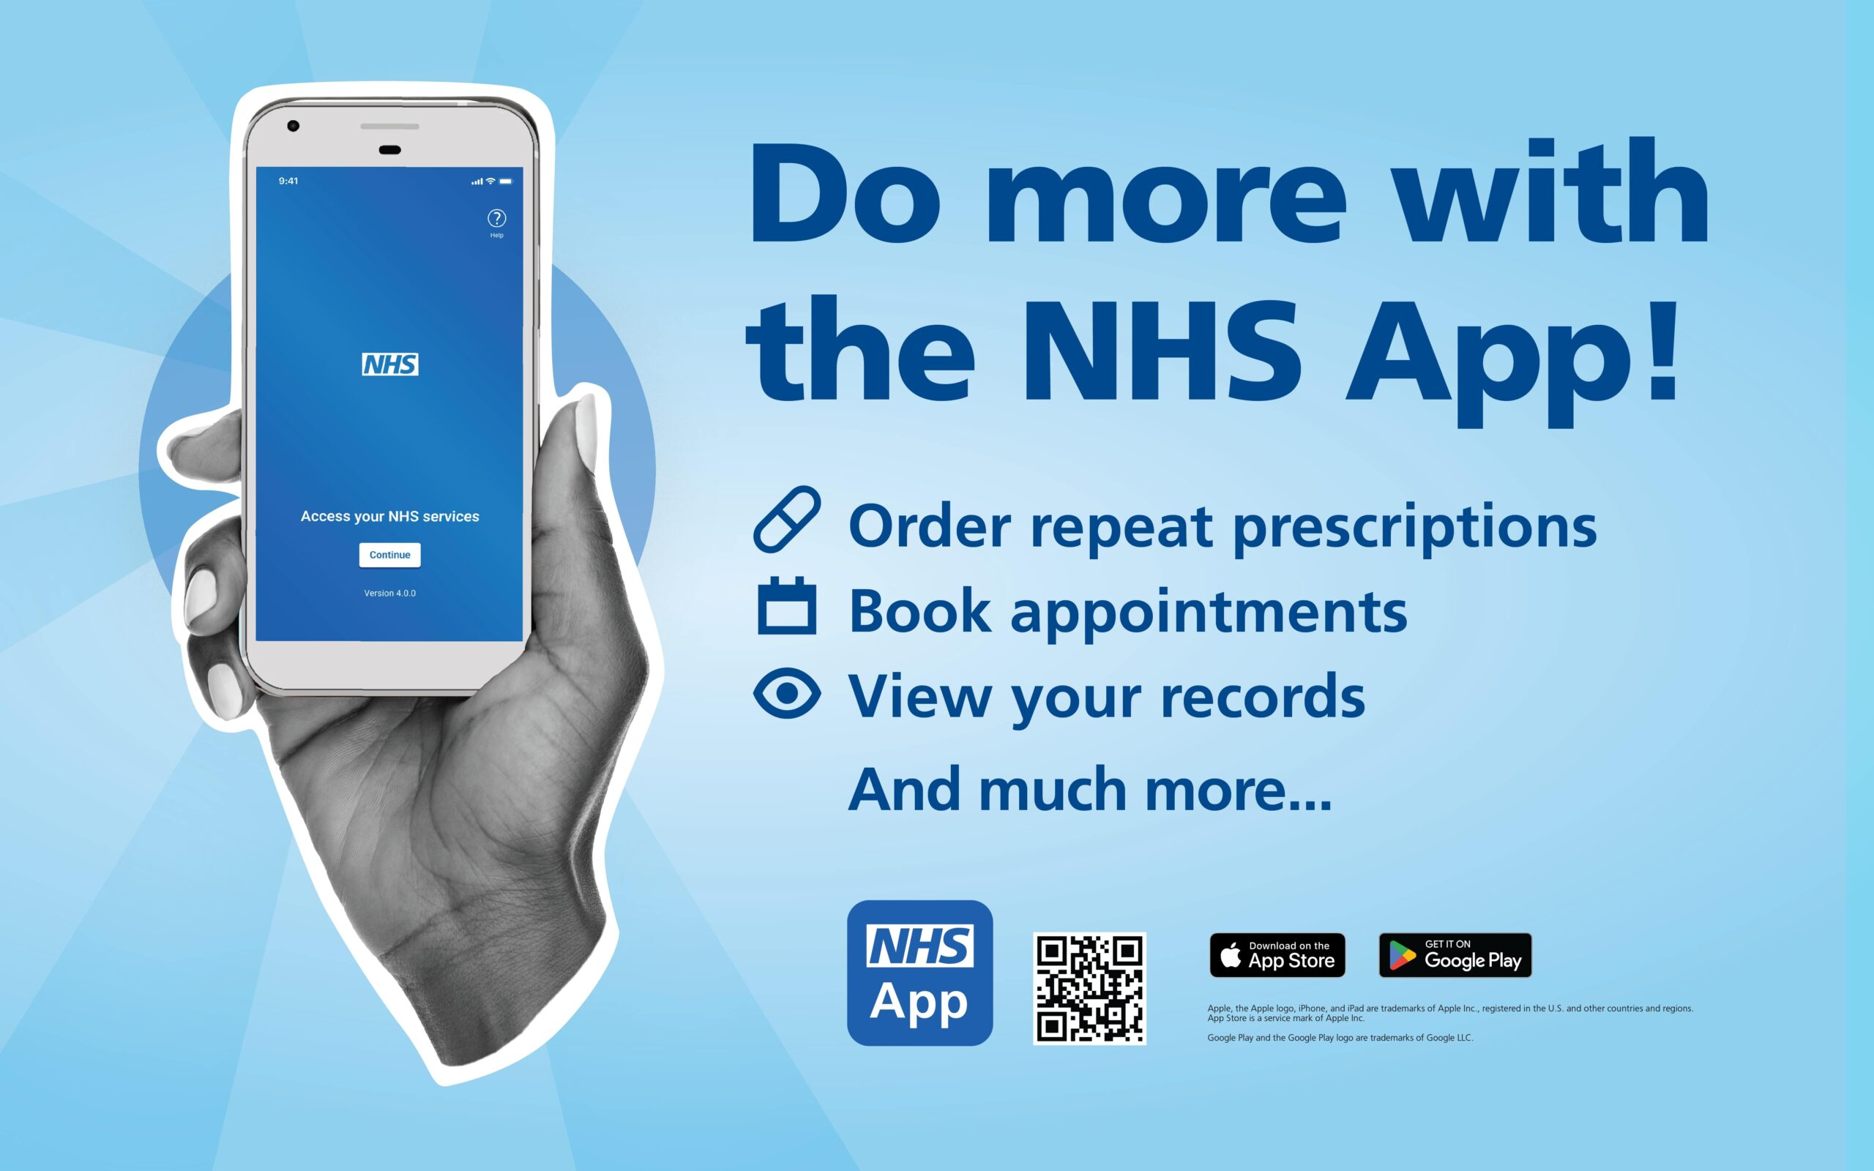
What does the NHS App do?
Use the NHS App to:
- check your symptoms
- find out what to do when you need help urgently
- book and manage appointments at your GP surgery
- order repeat prescriptions
- view your GP medical record securely
- register to be an organ donor
- choose how the NHS uses your data

We want to make sure you receive important updates from us. Due to changes outside our control, we must reduce the number of SMS messages we send.

Please register for the NHS App and turn on notifications—this allows us to send messages that appear to you like texts, but without the cost to the NHS.

If you can’t use the app, we can send messages by email.
Please make sure we have your current email address.

If neither option works for you, don’t worry—every patient who uses the app or email helps us keep SMS capacity for those who need it most.

Thank you for helping us stay connected and for supporting our efforts to keep everyone informed!



THE BRIMINGTON SURGERY
Working to deliver the highest quality care.
Every patient matters!

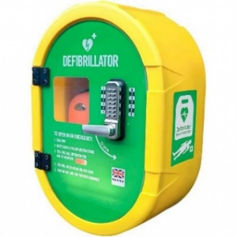
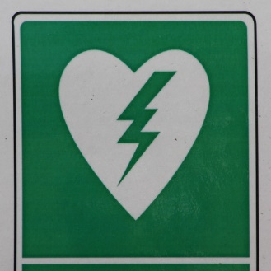
Flu vaccinations.
This year we have had a FANTASTIC uptake!
We are grateful for every patient who attended the surgery for their flu vaccinations.
The funding we receive for giving every vaccination goes straight back into patient care
Thank you to our amazing Team for a seamless campaign!
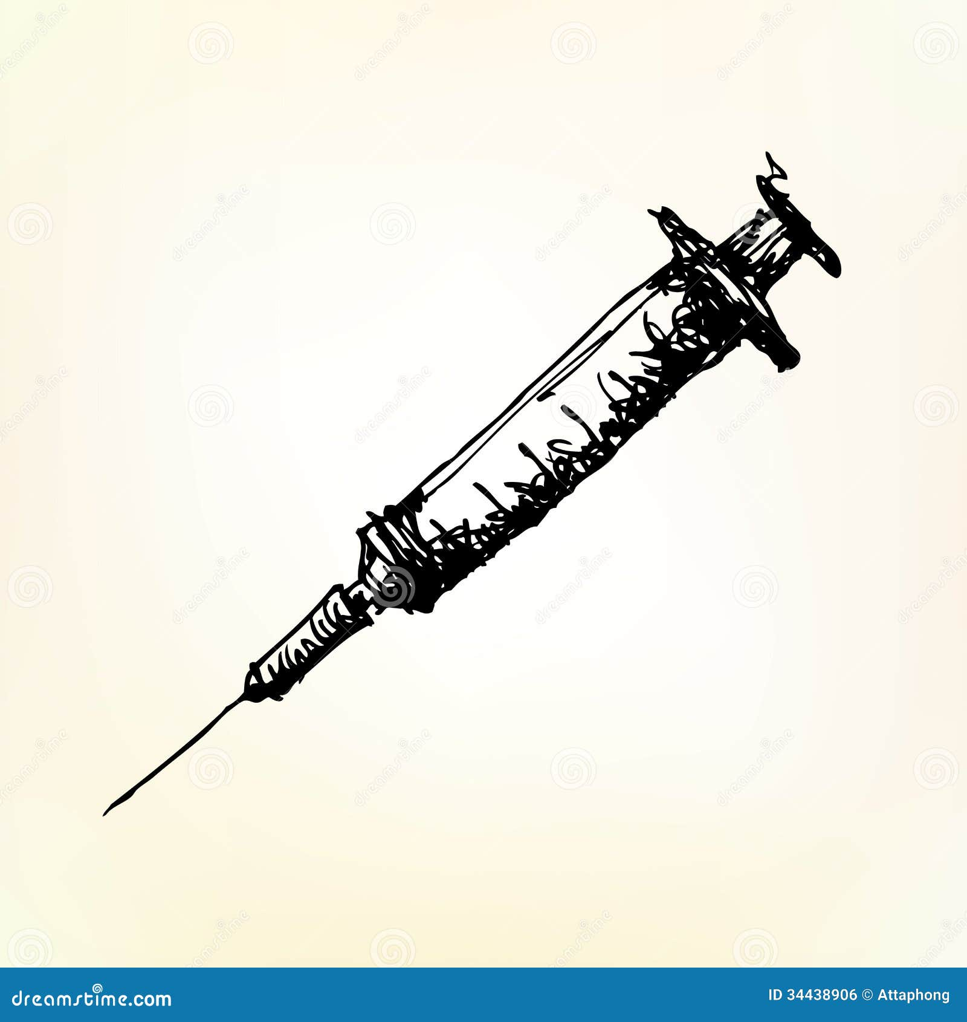

PLEASE REMEMBER TO CANCEL YOUR APPOINTMENT IF YOU CAN NOT ATTEND:
Phone the surgery main line or just leave us a message on 01246 212 840
PUBLICLY ACCESSIBLE DEFRIBRILATOR
THANK YOU FOR ALL YOUR HELP.
THIS HAS NOW BEEN INSTALLED NEAR THE
FRONT DOORS OF THE SURGERY.

Did you know your local pharmacy can help you get certain treatments quickly?
