
The Brimington Surgery -Patient Participation Group
NOTES March 2026

- Attendees: S Hague (SH); Chris Hudson (CH), M Nicholson (MN), M Varley (MV), M Liddle(ML), P Wright (PW), S Wetton (SW), J Bramley (JB), P Elliott (PE - Practice Manager)

- Apologies - F Gough,

- Brim PPG Guide – a "living" document:

Rules Governing the Group - The group shall elect a chair to serve for a period of two years (with a start date set of January) and will be elected at a PPG meeting.

There were no volunteers for Chair and Sue Hague is happy to continue – this was agreed.

Aims of the Group The group will develop short-term and long-term goals, reviewing these regularly.
Having aims and objectives will help the group develop purpose, something that some members felt was lacking.
Suggestions were:
- To recruit new members. Potentially young people. It would depend on how many members the group wishes to have. It was deemed very important to have effective people regardless of the size of the group. It was agreed that the offer to join the group is out there and it is patient choice but that most patients do not seem to know about the group despite leaflets and posters.

- Communications e.g. Newsletters; PR work about the impact of funding and NHS England contract impositions; Social Media presence and campaigns; having a PPG Facebook page. There was a discussion about contacting 6th Forms and Chesterfield College to see if there are any student who might need a project involving IT that could help us and the PPG help them?

- Patient Surveys – this would be helpful for the practice

- Noticeboards – for more members to be involved in helping keep these updated, very helpful for the practice and patients

- Events – e.g. Quarterly Carers' group? Or a Diabetes informal event PE happy to open the practice for an event. This would give the practice "added value".
Brimfest – the group do not feel that this is of interest.

MV felt that an overarching aim would be, to provide effective support and input into the practice with a beneficial viewpoint from the wider community. Also, that whatever the specific goals might be, they should all enhance and benefit the performance of the practice.

MV suggested that the group had a think and bring achievable ideas to the next meeting to enable the group to develop their purpose. This was agreed.
There was a brief discussion about why current members have joined and two members stated that they saw the information in reception and thought it was a good opportunity to give back into the community.

The Website – There has been an IT development to help PPGs communicate with patients. It was agreed to set up a trial with ML to see if this is beneficial.
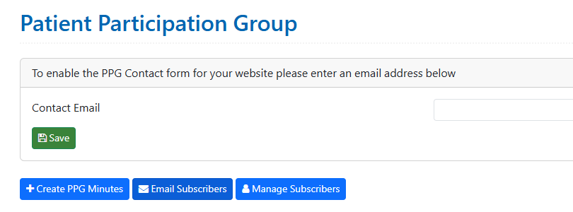

- Marie Curie had a speaker at the Regional PPG and they have funding to work with GPs. PE unsure if Brim Surgery has been approached. Local hospice has ongoing funding issues. Marie Curie does a lot more than people might realise.

- Covid jabs The vaccinations the practice will get are Moderna – the practice is not given a choice.

- Requesting BP readings online (SH) Why are patients being asked to submit BPs via messaging? PE stated that it will be that the Practice will require this information and it was requested by a GP or Nurse. To call everyone in every time a BP is required would mean that the practice would be completely swamped. The messages will clearly state that where someone could not do this from home they could still book an appointment at the practice.

- Pt feedback - (standing item)
Family and Friends Test – see attached

- Surgery News – (standing item)
We are pleased to welcome Drs Aderemi Ayegbusi and Priya Patel; New Patient Support Team member Alex.

New IT systems – we will continue to use the telephones, but if you can use online forms then you may be asked to do so. In certain circumstances a member of the Patient Support Team may go through a form with you. Some phone calls will therefore be longer and some quicker. Forms help give the clinician extra information so they can triage better for same day appointments or safely allocate a 2-day or 7-day appointment.

- Date of next meeting - June 17th 10am

FAMILY & FRIENDS TEST:

Nov - 11 responses 100% Good/Very Good DEC - 35 responses 100% Good/Very Good
Jan - 14 responses 100% Good/Very Good Feb – 15 responses 100% Good/Very Good

Always pleasant and helpful in surgery, never kept waiting |  | The doctors are very nice and helpful. | The doctor I dealt with was wonderful— nice and understanding, made me feel heard
Fast response to call for appointment |  | Always get good help from receptionists, not just dismissed, makes a big difference when feeling ill | Everyone listens and helps from the moment the phone is answered through to appointments and treatment thank
Wonderful staff and although time (booking) can be a little extended in severe need they are generally short or the same day. I have been a patient for decades and wouldn’t want to change |  | Been a patient for 55 years never had no issues thank you for the service | I was seen to promptly and examined to see what the problem was
Saw me same day … relieved and pleased |  | The staff at this surgery are exceptional!
Every time I've rang I've got an appointment and very polite staff. |  | On occasion communication could be better. We aren't always aware of where to get prescription from
Service always good and caring. When we have rung at 8am always received quick phone call or appointment usually same morning. Doctors and staff always seem professional and pleasant. |  | Friendly receptionists, very accommodating. Appointments run timely, Good advice. Very clean surgery. When
Good quality care, always get seen, don't have to wait long | Receptionists listen and act appropriately. Doctor phoned back with very helpful advice

